Event Date:
Food Drive bags …..…………...March 13
St. Patrick’s Day ………………..March 17
Food Drive Bags Pick-up…….March 20
March Birthdates:
Here are our birthday students for March. If you see them remember to say “Happy Birthday”!
Katie Bartlett March 12
CCD Service Project:
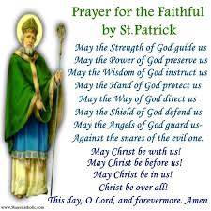
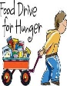
Food Drive. We will be doing another food drive during Lent. The hanging food bags will be March 13 10:00 am until done. The food bags pick up will be March 20 from 2:00 pm until done. The food donations will be taken to “God Storehouse” in Meriden to help the needs of our brothers and sisters. All CCD families are asked to help with this spiritual habit.

March Saint
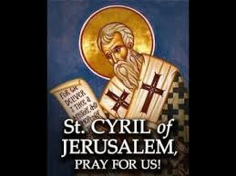
Here are two saints to remember this March. March 18th St. Cyril of Jerusalem was biblical scholar, a cleric in the Church of Jerusalem, and eventually bishop of Jerusalem. He was embroiled in the political and doctrinal controversies following the Nicene council and defended the Nicene Creed against the Arians. His twenty-four surviving homilies summarize the beliefs and the theological traditions of the Jerusalem community. May we learn from him that, having “entered on a good and most glorious path,’ we must “run with reverence the race of godliness.”
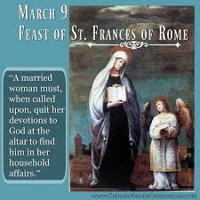
March 9th St. Frances of Rome was married at age thirteen and had six children. The death of her two children sensitized her to the needs of the less fortunate. She took care of the poor, the sick, and the needy. Other women soon joined her in a life of prayer and caring for others as Benedictine oblates. Frances founded a monastery for the oblates and remained its superior until her death. May we imitate her generous spirit and ability to attract others to help those in need, especially grieving wives and mothers.
Stations of the Cross Do to the lack of interest we will not be doing a youth Stations of the Cross this year.
Religious Education Director Note
We are in the sixth month of CCD. We are still looking for volunteers that would like to teach next CCD year. If you are interested, please let us know. Thanks!

