Event Date:
Confirmation Retreat …………October 25
Halloween ……….………………..October 31
Food Drive Bag ….….…………..November 7

October Birthdates:
Here are our birthday students for October. If you see them remember to say “Happy Birthday”!
Alice Henry Oct. 1st
Liam Ellis Oct. 11th
Kennedy Gulifoyle Oct. 12th
Ruby Johnson Oct. 14th

Food Drive Service Project:
Nov. 7th – Nov. 14th
We are asking each CCD Students and their family to help to do a Food Drive for the needy in our community. We would like the younger students to hang food bags Nov. 7th and then Nov. 14th the older students pick up the filled food bags. We will be delivering the food bags to “Gods Store” in Meriden.

Pfluam Program Corner:
This program first unit has been taking us on a journey through several parables from Gods vineyard; the Two Sons; the Wedding Feast; Caesar and God; the Beatitudes; and finally the Wise and foolish girls.
The second unit of this program will be handed out starting November 1st after Mass.

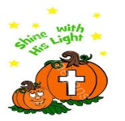
Halloween Event. We will not have a Halloween event this year.

October Saint
Here are two saints to remember:
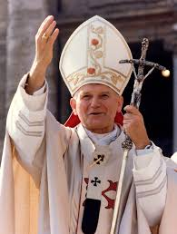
Oct. 22nd we are honor St. John Paul I, who was born in Poland. He is known for his efforts to end Communist rule and strengthen Catholic ties with other religions. St. John Paul II became pope in 1978. Also he established the Second Sunday of Easter as Divine Mercy Sunday.
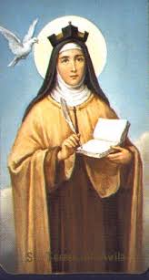
Oct. 15th we honor St. Teresa of Jesus, Born in Avila, Spain. She join the Carmelite convent, advanced in prayer and experienced visions. She help reformed (Discalced) Carmelite order of nuns and friars. Teresa wrote the classic spiritual literature “The Interior Castle”. May we follow her advice: “accustom yourself continually to make many acts of love, for they enkindle and melt the soul.”
Religious Education Director Note
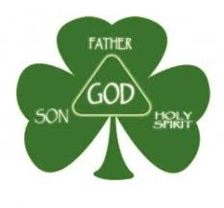
We are separated but we are together with GOD. We are learning from a distance but we are still learning the same about our GOD. At Mass we share in the Eucharist. We consume the body and blood of Jesus. We are all members of GOD family.

