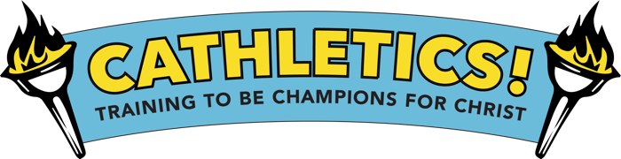
St. Theresa Catholic Church
Child Registration Form
Dates / Location: July 18th – 22nd, 2022 Parish Hall, Perry, KS Time: 9:00 - noon
===================================================================================
Child’s Information:

Name: _________________________________________________________________________

Gender: M F Age: ____________ Grade completed: _____________

T-shirt size: (circle one) child sizes : XS S M L / adult sizes: S M L XL

Allergies or medical conditions: ______________________________________________________

Health Insurance # (if applicable): ____________________________________________________

Family Information:

Parent/Guardian Name: _____________________________________________________________

Address: ____________________________________ Email: _____________________________

Phone Numbers:

Home: __________________________ Cell: ____________________________

Emergency Contact:

Name: ____________________________________________ Phone: _______________________

I understand that reasonable precautions will be taken to safeguard the health and well being of the participants in this VBS and that I will be notified as soon as possible in the event of an emergency. In the case of sickness or an accident, I authorize and consent the VBS Team, or other associated volunteers of the VBS program to obtain medical care from a licensed physician, hospital, or medical clinic for my son/daughter in the event that myself or other legal guardian(s) cannot be reached. I hereby do release and forever discharge Cat.Chat Productions Inc., this Diocese, and this Parish from all manners of actions, claims which I or the child named above shall or may have for any reason, arising during my child’s attendance of the VBS.
Unless other written instruction is submitted, I also consent to allowing my child’s image to be recorded, either by photograph or video, and used during the VBS week or for future advertisement of Cat.Chat VBS programs.

Parent / Guardian Signature Date
Return completed form by June 5, 20200 